海盗船 --- 温湿度检测功能

Pirate Ship- Temperature & Humidity Testing

**硬件材料**

**HARDWARE**

* DHT11温湿度传感器 × 1

DHT11 Temperature & Humidity Sensor

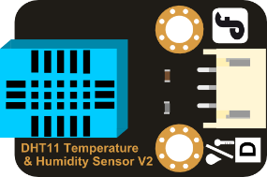

* 数字触摸开关 × 1

Digital Touch Sensor / Touch Sensor

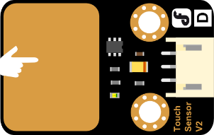

* I2C LCD1602液晶模块 × 1

I2C LCD1602 LCD Module

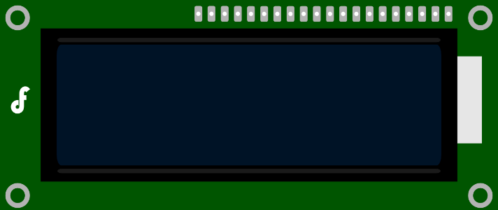

* M3*6尼龙柱、尼龙扎带 × 若干

Several M3*6 Nylon columns & Tie-wraps

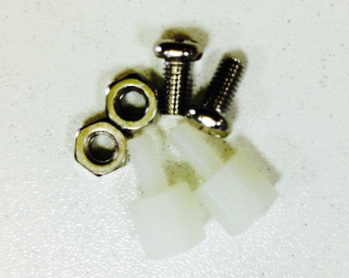 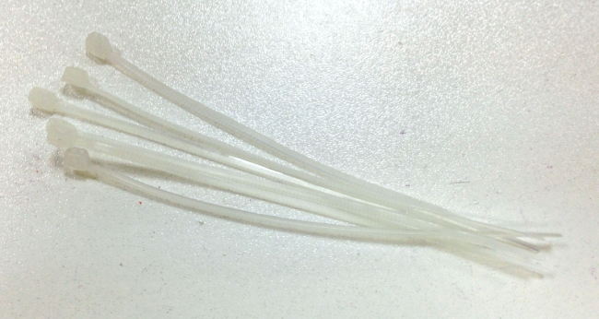

**组装步骤**

**HOW TO ASSEMBLE**

准备完以上这些材料，就开始组装了，组装不难，更着操作就行。

Now as we have all the components prepared, let’s start assembling. It’s quite easy. Just follow me and have fun.

**STEP 1: 安装触摸传感器**

**STEP 1: Add the touch sensor to the car**

尼龙柱是用来固定传感器的，先将尼龙柱固定到触摸传感器的两个固定孔上。注意不要拧的过紧。

There are two holes for the Nylon columns in the touch sensor. Fix the Nylon columns on the sensor. And I know some of you just cannot help twisting the column like an OCD. I totally get that. But I would still like to remind you not to over-twist those columns.

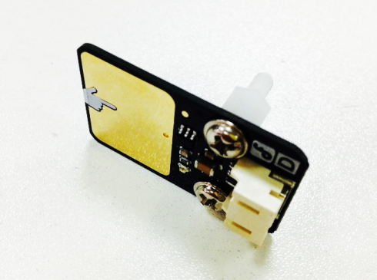

完成后，再将传感器固定到车身前端的传感器板上。下图为正反面。

Once completed, attach the touch sensor to the sensor plate located at the fore end of the bodywork just as it is shown in the picture below.

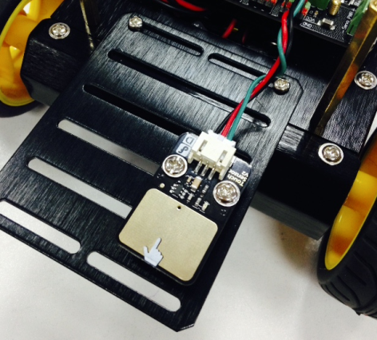 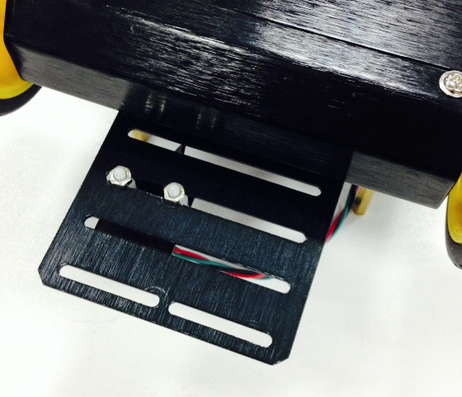

**STEP 2: 安装LCD屏**

**STEP: Add the LCD Screen**

取出4根尼龙扎带，依次将LCD屏上的4个固定孔和小车的支撑柱固定在一起。将多余的线减去即可。

Slide the shores into the four holes in the LCD screen and fix them on the car with four tie-wraps. Then cut the remaining part of the tie-wraps.

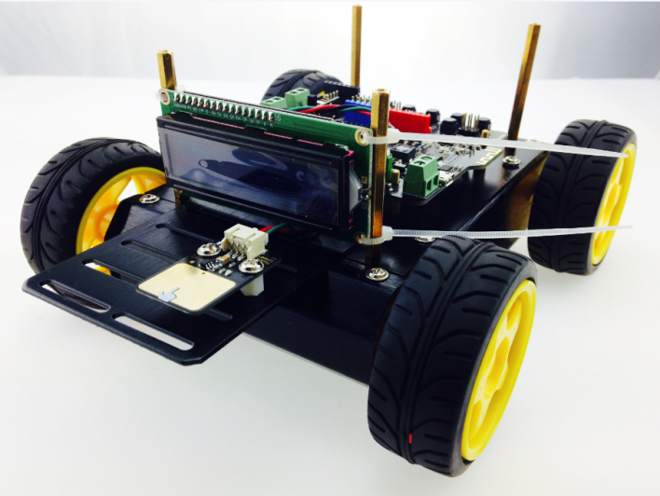

**STEP 3: 安装DHT11传感器**

**STEP: Assemble the DHT11 Temperature & Humidity Sensor**

还是先将尼龙柱固定到DHT11传感器上，如下图所示。

Fix the Nylon columns on the DHT11 Temperature & Humidity Sensor just as it’s shown in the picture below.

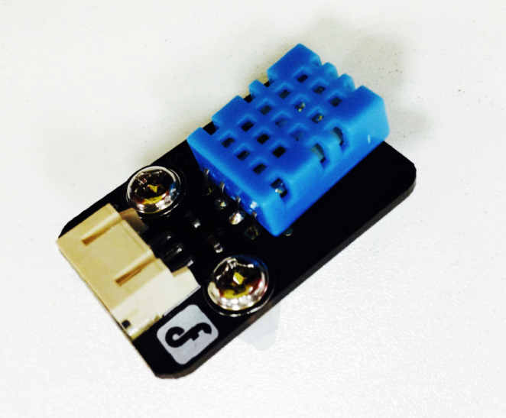

再用螺母将其固定到小车的顶板上，完成后，建议不要急于将顶板固定在小车上。因为我们

下一步就需要电路连接了。

Attach the DHT11 Temperature & Humidity Sensor to the upper plate of the car by fastening the nuts for the tie-wraps. But now it’s still too early for fixing the upper plate onto the car as we need to work on the electric circuit connection.

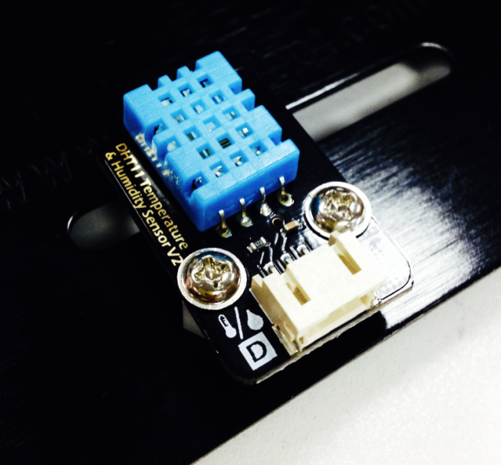 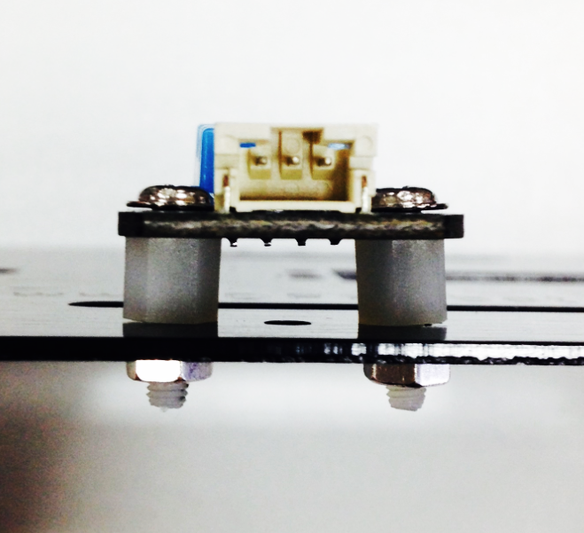

**STEP 4: 完整效果图**

**SETP 4: What It Looks Like When Finished Assembling**

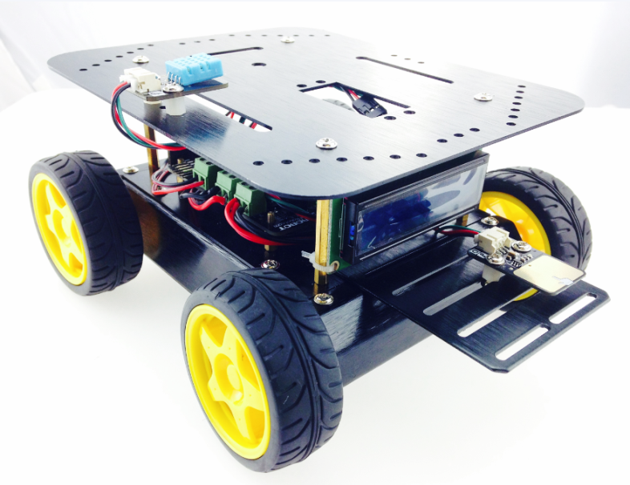

**硬件连接**

**Hardware Connection**

安装完成后，我们就要开始电路连接了，参照我们下图的硬件连接图。只需将传感器的3Pin引脚直接连接到Romeo BLE上即可。

Now it’s time for electric circus connection. All you have to do is to connect the 3pins on the sensor to the Romeo BLE.

注意线序：传感器的绿色为信号线，红色为VCC，黑色为GND。LCD显示屏依次接VCC，GND，SCL，SDA。

Keeping cables in order is quite important. The green cable represents the signal one; the red one stands for VVC and the black one represents GND. The LCD monitor shall be connected to VCC, GNC< SCL and SDA in that particular order.

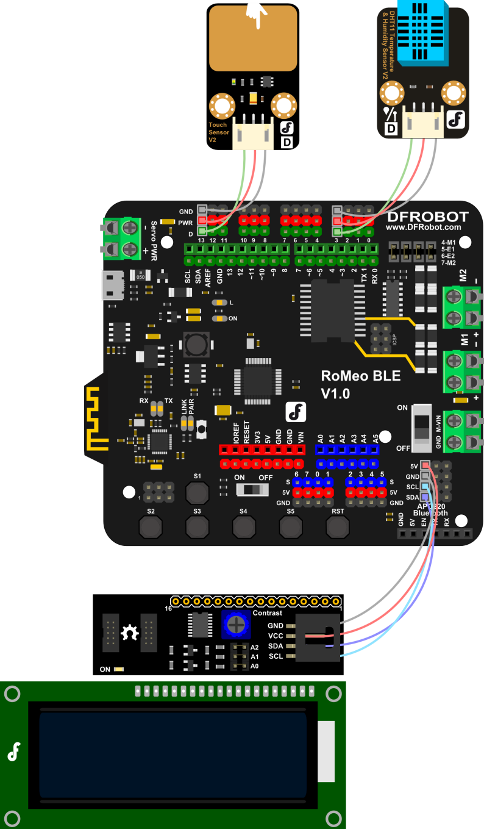

**输入代码**

**Type in the Code**

插上USB线，下载代码。由于代码较长，所以这里就不全部显示出来，你可在软件包中找到 DHT11_Display.ino的代码，下载进去后即可。不要忘记加载LiquidCrystal_I2C和dht11的库。

Download the code first. The following picture only shows a part of the coding. You can find codes named DHT11_Display.ino and then download. And don’t forget the KUs for LiquidCrystal_I2C and dht11.

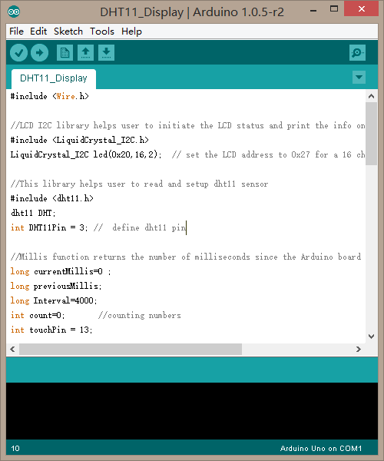

如果一切都顺利的话，下载成功后，用手轻触两下触摸传感器，你就可以在LCD屏上看到实时显示的温湿度的值了。触摸传感器在这里起到两个作用。

If everything goes smoothly and you’ve successfully downloaded the coding, real-time temperature and humidity will be shown on the LCD screen. Hereby the touch sensor functions in two ways.

第一个作用： LCD背光灯的开关作用，轻按触摸传感器，背光灯会打开，长时间不按，又会自己关闭，节约电源。

First, it functions switch of the LCD backlight lamp. If you don’t touch the sensor for a long period, it will turn itself automatically, which is energy-conservative.

第二个作用：屏幕切换作用，当你用到多个环境传感器的时候，触摸传感器就能起到很好的屏幕切换的作用。通过切换可查看多个环境监测数据

Secondly, when you have several environment sensors, touch switch can help quickly help you cut among different pages where you may see different environment monitoring data.

**代码回顾**

**Review of Codes**

代码开始还是一些库函数的声明，库很重要，工程师已经将一些很复杂的数据处理部分写在库中了，你没有必要理解这么深奥的理论知识，只需要会使用就可以了。所以，如果没有库，也就没有看上去那么容易理解的代码了。

Here is some highlight for the KU first. Ku is quite important and engineers have already written some part with complicated data processing in the KU. It’s unnecessary for you to understand such abstruse theory as long as you know how to use it. Thus, it won’t be easy to understand code without KU.

#include <Wire.h>

#include <LiquidCrystal_I2C.h>

LiquidCrystal_I2C lcd(0x20,16,2);

#include <dht11.h>

dht11 DHT;

这里你需要了解一下DHT11Pin，这个变量是用来声明传感器引脚的:

Here you need to know about DHT11Pin, a variable that is used to highlight the sensor’s pins

int DHT11Pin = 3;

这里的意思就是说，DHT11Pin代表的3号数字引脚。换言之，我们的DHT11传感器是接到数字口3。

Namely, DHT11Pin represents the third pin. That is to say, our DHT11 sensor is connected to digital port 3.

如果说，你想用数字口4来控制DHT11传感器的话，代码可以如何修改呢?

int DHT11Pin = 4;

What if you want to control the sensor with the fourth digital port, how would you modify the codes?

将3替换成4就可了。如何变化引脚，你是需要学会的，应该不难。

It’s quite easy. You just need to replace 3 with 4.

下面这串是一些时间变量的声明，下面会有说明。touchPin对应的就是触摸传感器，13号数字引脚。

The followings are some highlights for the time variables. touchPin represents touch sensor while 13 stands for digital ports.

long currentMillis=0;

long previousMillis;

long Interval=4000;

int count=0; //counting numbers

int touchPin = 13;

进入setup()函数，是一些初始化设置

Bring in the function of setup(), which is a setting-up for the initation.

pinMode(touchPin,INPUT);

将触摸传感器设置为输入模式，具体可参看Arduino语法手册pinMode()函数介绍。

接下来，初始化LCD屏，并且打开一次LCD灯的背光灯，表示LCD上电开始运作。

lcd.init();

lcd.backlight();

Then keep the touch sensor with a type-in mode. For specific information, you may check the Arduino Handbook for the introduction of the function of pinMode().

接着进入loop()函数中，首先需要读取触摸传感器的值，用touchState这个变量来存储读到的值。

Now it’s turn for the function of loop(). First we need to read the figure from the touch sensor and then store those figures with one variable: touchState

int touchState = digitalRead(touchPin);

紧接着就是判断，是不是有手触碰传感器，如果有手触碰传感器，也就是说控制器会读到HIGH这个信号。那么count就会加1（可查看自加++用法）。

Then check if the controller will receive a signal of HIGH once you touch the touch sensor with you fingers, 1 shall be added to the count.

if (touchState == HIGH){

count++;

previousMillis= millis();

}

这里count是用来记录按下的次数的。并且，每按下一次，就用millis()函数记录下时间。

Hereby count means how many times you have touched the screen. But if you only touch the sensor once a month, then the amount of time for each touch will be included in the function of millis().

通过if语句，不断和前一次按下的时间做比较。Interval，在这里就是设置的时间点，4000ms(也就是4s)。如果4秒内有手接触触摸传感器，那么执行些什么动作。超过4s又执行些什么动作。

We change the length of touch time with a sub sentence initiating with if. Interval here means the period for touch we set up. Thus, we know what action shall be taken within four-second of touch and more than four seconds’ touch respectively.

if(currentMillis - previousMillis < Interval) {

//4秒内，执行些什么

else{

//超过4秒，执行些什么

}

我们先看超过4秒的，比较容易理解：

What action shall be taken when we touch the sensor for more than four seconds

lcd.setBacklight(0);

setBacklight()这个函数是用来关闭LCD背光灯的。

The function of setBacklight() is used to turn off the LCD backlight lamp

超过4秒，我们知道可以关闭LCD背光灯。

If we touch the sensor for more than four seconds, we know that the LCD backlight lamp can be turned off.

那么不超过4秒呢？执行些什么动作？

what action shall be taken within four-second of touch

if (count==1){

// 按下一次 LCD屏幕不做任何反应

} One touch, the LCD screen won’t show any difference

else if (count==2){

// 连按二次 LCD屏幕才显示温湿度的值

Touch twice, figures of temperature and humidity will be shown on the LCD screen

}

如果4秒内，传感器被按下一次，那么屏幕仍然保持关闭状态。只有当被连按两次的时候，LCD背光灯才被开启，显示温湿度传感器的值。

Press the touch sensor one more time within four seconds; the screen would still be off. Only if you touches it twice at the same time, will the LCD backlight be on and figures of temperature and humidity be shown

这里有一点需要注意，再最后一次按下后，count要被清零，那么下次监测的时候才能又从0开始计数了。

Please remember to keep the count as zero after you touch the sensor for the last time

count=0;

所以对应的完整代码就是：

Thus the complete code shall be

if (count==1){

lcd.setBacklight(0);

}

else if (count==2){

lcd.backlight();

DHT11Show();

count=0;

}

这里数据读取完之后，需要记录下当前的时间(currentMillis)，可与前面的时间(previousMillis)做个比较，这一点也很重要。

Then we need to keep a track of the current time as we can compar.e it with (previousMillis)

currentMillis = millis();

这里还涉及一个函数DHT11Show()，可以从函数的名字上猜出，这个函数是用来显示DHT11传感器的数值的。依次来看下：

Once more function involved: DHT11Show(). It’s not hard to guess that it’s used to show the figure for the DHT11 sensor.

int value = DHT.read(DHT11Pin);

DHT.read(pin)函数是用来从DHT11传感器引脚上读取传感器的数据。

The function of DHT.read(pin) is used to read data read from the pins of DHT11 sensor.

下面这部分全部是LCD屏的一些相关用法：

Here is how we would used the function related to LCD screen.

lcd.setCursor(0,0);

lcd.setCursor(0,1);

setCursor(column,row)函数是用来设置光标显示的行与列的位置，从0开始计算。

比如说(0,1)也就是说，从第一列，第二行开始显示数据。

The function of setCursor(column,row) is used to demonstrate which column and row the cursor is shown, starting from zero within the brackets.

lcd.print(DHT.humidity,1); // 显示湿度 It shows humidity

lcd.print(DHT.temperature,1); //显示温度 It shows temperature

print()函数可直接在屏幕上显示该数据。

print() means this figure can be shown on the screen directly.

lcd.print(" ");

上面这句语句表示在屏幕上输出”空格”,作用是用来清屏的。

lcd.print(" ") means blank space shown on the screen. It’s used to clear the screen.

**多传感器结合**

**A Combination of Multiple Sensors**

可能你在选购的时候，用到了多个传感器环境监测的传感器，那该如何将它们全部结合起来呢？

How can you combine multiple sensors once you need a couple for the environment monitoring?

不用担心，我们提供给你一个多传感器检测的代码模板，你可参照模板来进行修改。其实原理和单个传感器是一样的，只是中间LCD屏幕切换部分多增加了几个环节。

Don’t worry. We will offer you guys a coding template for the testing of multiple sensors. You can make adjustments of the combination by referring to the mentioned template. In fact, the theory is the same as single sensor except that there are for steps for the changes/cuts of LCD screen.

如下所示的代码，红色标注的部分就是需要修改的部分。在前面代码回顾中讲到，count是用来手指触摸传感器的次数的，所以count=2表示按下两次，让它显示第一个传感器的数值。那么如果增加一个传感器，我们就记count=3，被按下第三次的时候，让它显示第二个传感器的数值。依次类推……不要忘记再最后一个传感器显示结束之后，需要将count清零。

The coding in red below needs to be modified. We mentioned before that count refers to how many times fingers touch the sensor. Thus, count=2 means that we have pressed twice and it shows the figures for the first sensor. Keep going! Please bear in your mind that you shall keep the count zero again.

样例代码:

Sample Coding

if(currentMillis - previousMillis < Interval) {

if (count==1){

lcd.setBacklight(0);

}

else if (count==2){ //No.1 Sensor

Sensor1Show();

lcd.backlight();

else if(count==3){ //No.2 Sensor

Sensor2Show();

lcd.backlight();

count = 0;

}

}

当然，传感器的一些初始化设置不能少，也就是代码开始的变量声明，以及独立的Show()函数。否则控制器无法读取到传感器的数值。

Of course, initiation set-up, highlights for variables at the beginning, for the sensor is important.

如果还不是很清楚如何修改你的代码，可查看我们提供的**WeatherStation.ino**的样例代码。

You can check the sample code named WeatherStation.ino for reference if you still have no idea how to modify your codes.